Disabling the shock sensor

- Click on the arrow near your clock and then double click on the shock sensor icon. 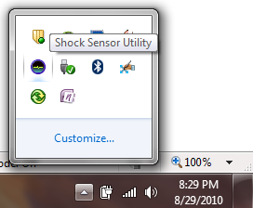
- Click on the red part of the circle that appears. 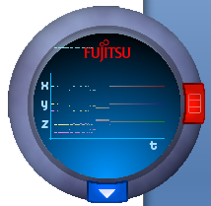
- Then choose nothing and click OK. 